E-COMMERCE ORDER MANAGEMENT DATABASE SYSTEM

3. SELLER & INVENTORY TABLE DESIGN

1. Seller Table
The Seller table is designed to store and maintain the details of different sellers or suppliers in the E-Commerce Order Management Database System. Each attribute is assigned a suitable data type and constraint for proper storage of seller information.
S.No | Field Name | Data Type | Constraint | Description
1 | Seller_ID | VARCHAR(10) | PRIMARY KEY | Identifies each seller record uniquely
2 | Seller_Name | VARCHAR(100) | NOT NULL | Stores the name of the seller or company
3 | Email | VARCHAR(100) | UNIQUE, NOT NULL | Stores the seller's email address
4 | Phone | VARCHAR(15) | NOT NULL | Stores the seller's contact number
5 | Address | VARCHAR(200) | NOT NULL | Stores the seller's location

2. Inventory Table
The Inventory table is designed to store and maintain the stock details of products supplied by sellers. Each attribute is assigned a suitable data type and constraint for proper management of inventory information.
S.No | Field Name | Data Type | Constraint | Description
1 | Inventory_ID | INT | PRIMARY KEY, AUTO_INCREMENT | Identifies each inventory record uniquely
2 | Product_ID | INT | FOREIGN KEY, NOT NULL | Connects the inventory with its product
3 | Seller_ID | VARCHAR(10) | FOREIGN KEY, NOT NULL | Connects the inventory with its seller
4 | Stock_Quantity | INT | NOT NULL, DEFAULT 0, CHECK | Stores the available quantity of the product
5 | Stock_Status | VARCHAR(20) | NOT NULL, CHECK | Stores the current stock availability status
6 | Last_Updated | DATE | NOT NULL | Stores the date when the stock was last updated

4. ATTRIBUTE DESCRIPTION
- Seller_ID: Unique identifier for each seller.
- Seller_Name: Stores the seller or company name.
- Email: Stores the seller's email address.
- Phone: Stores the seller's contact number.
- Address: Stores the seller's location.
- Inventory_ID: Unique identifier for each inventory record.
- Product_ID: Connects inventory with the corresponding product.
- Seller_ID: Connects inventory with the supplying seller.
- Stock_Quantity: Stores the number of products currently available.
- Stock_Status: Stores whether the product is Available or Out of Stock.
- Last_Updated: Stores the date when the inventory was last updated.

5. CONSTRAINTS
- PRIMARY KEY: Uniquely identifies Seller and Inventory records.
- AUTO_INCREMENT: Automatically generates the Inventory_ID.
- NOT NULL: Ensures important information is provided.
- UNIQUE: Prevents duplicate seller email addresses.
- FOREIGN KEY: Connects Inventory with Product and Seller tables.
- CHECK: Ensures Stock_Quantity is not negative.
- CHECK: Allows only Available or Out of Stock as Stock_Status.
- DEFAULT: Sets Stock_Quantity to 0 when no value is provided.
- ON DELETE RESTRICT: Prevents deletion of referenced products or sellers.
- ON UPDATE CASCADE: Updates related foreign-key values when referenced IDs are changed.

6. SCREENSHOTS

Figure 1: Seller Table Creation

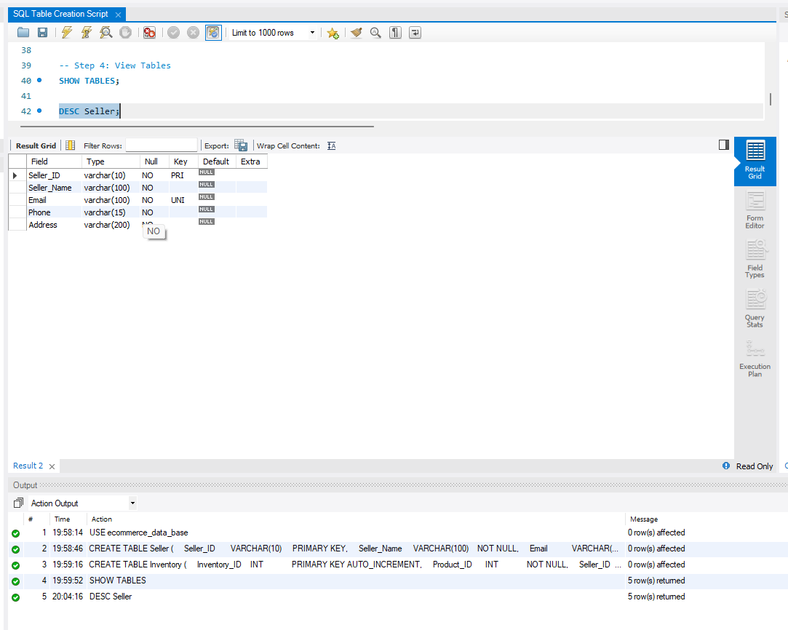

Figure 2: Inventory Table Creation

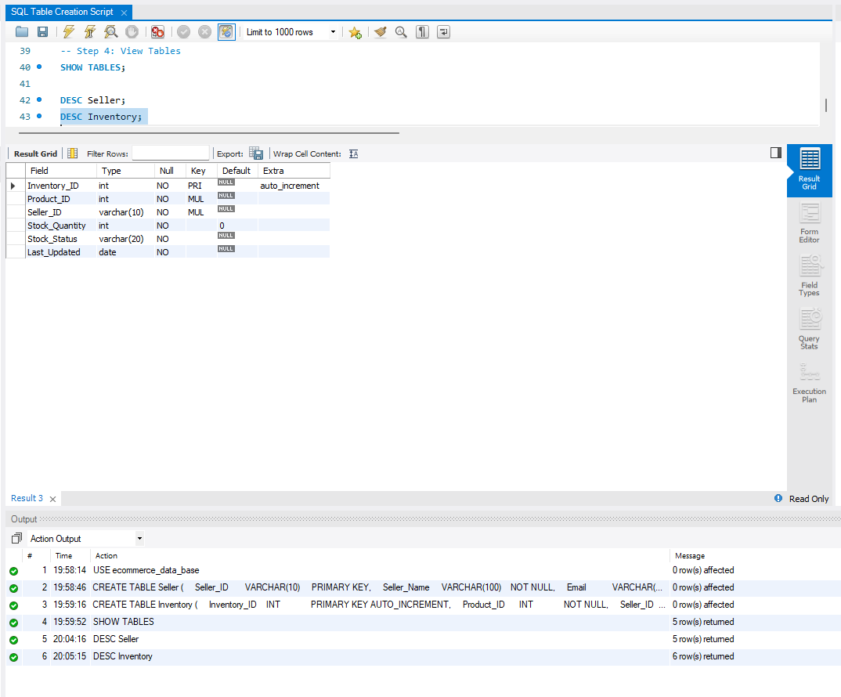

Figure 3: Table Creation Verification

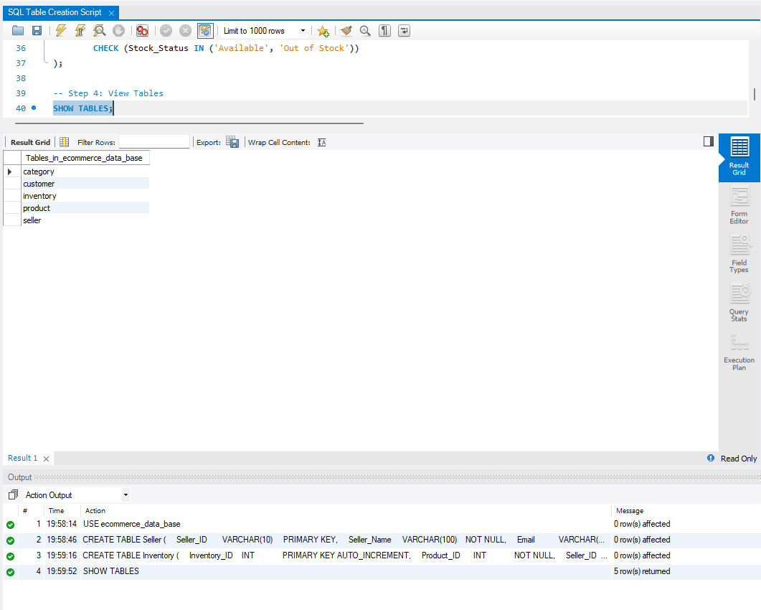

7. CONCLUSION
The Seller and Inventory tables provide the required structure for storing seller details and managing product stock information in the E-Commerce Order Management Database System. The defined attributes, data types, relationships, and constraints help maintain accurate, organized, and consistent inventory data.

